9/12/2024

**Uzair Ali S/O Yar Muhammad Memon**

**B-S CS III Section A**

**023-23-0350**

**To: Ma’am Marina Rajpoot**

Data Structures

Assignment 2 exercise Solution

**Task**

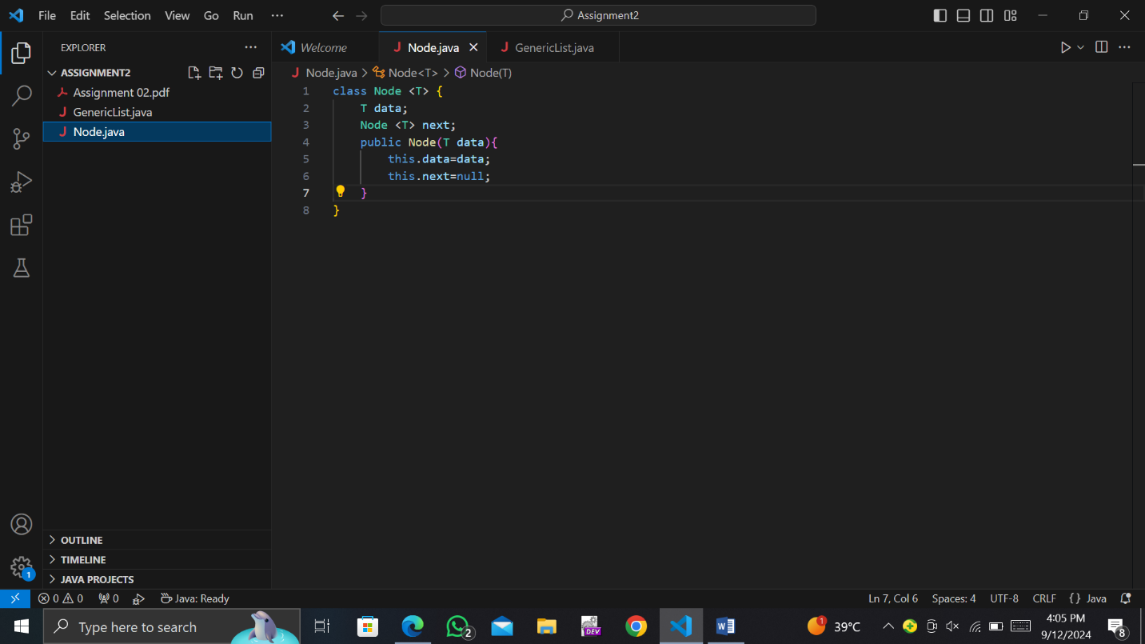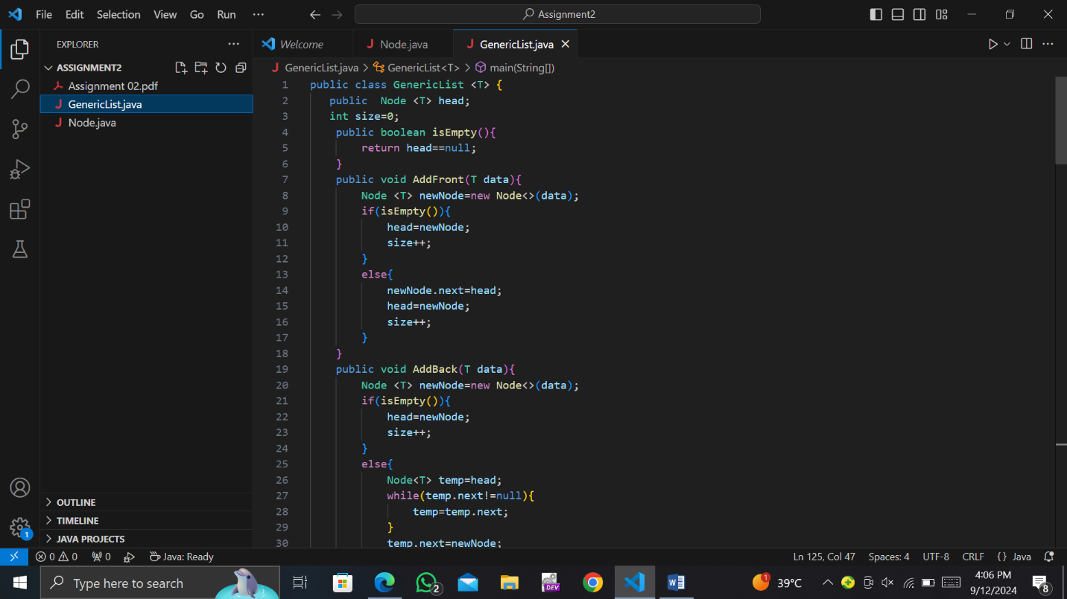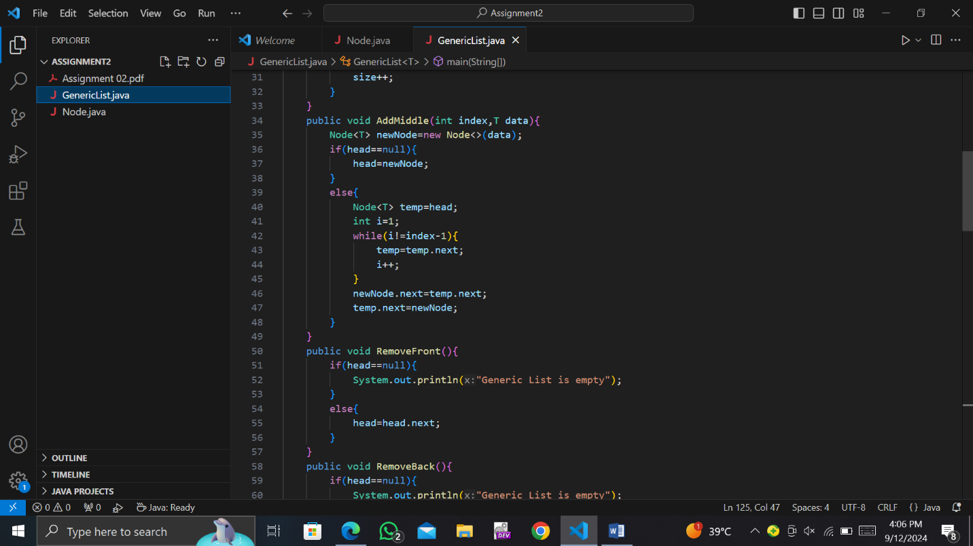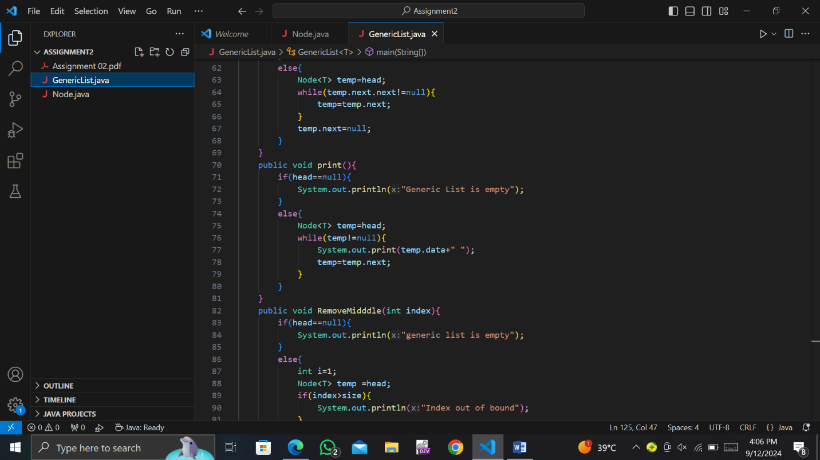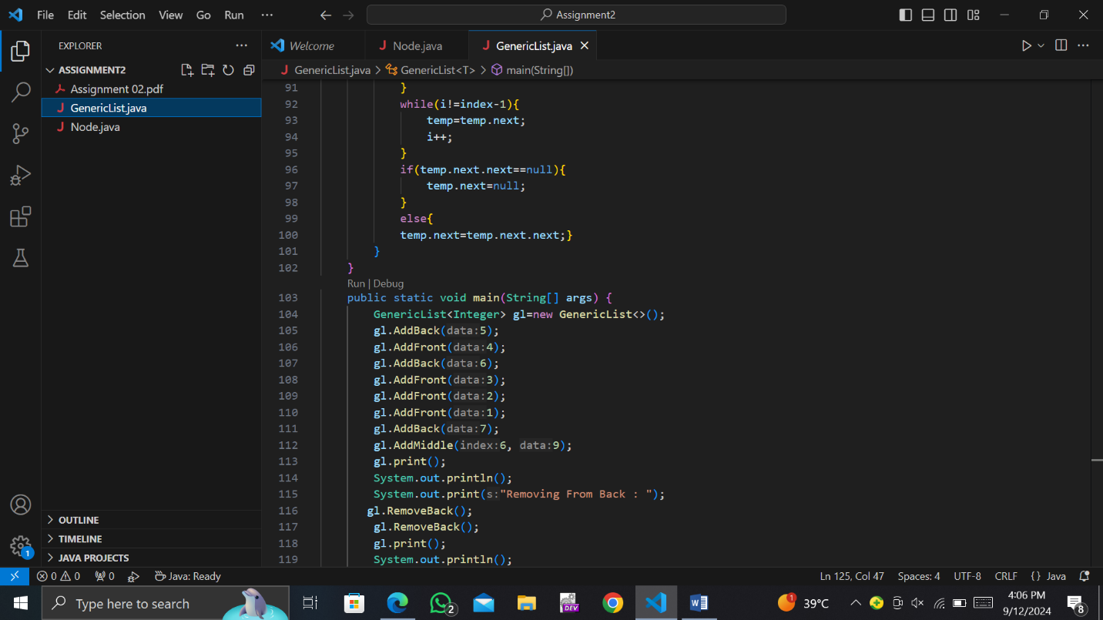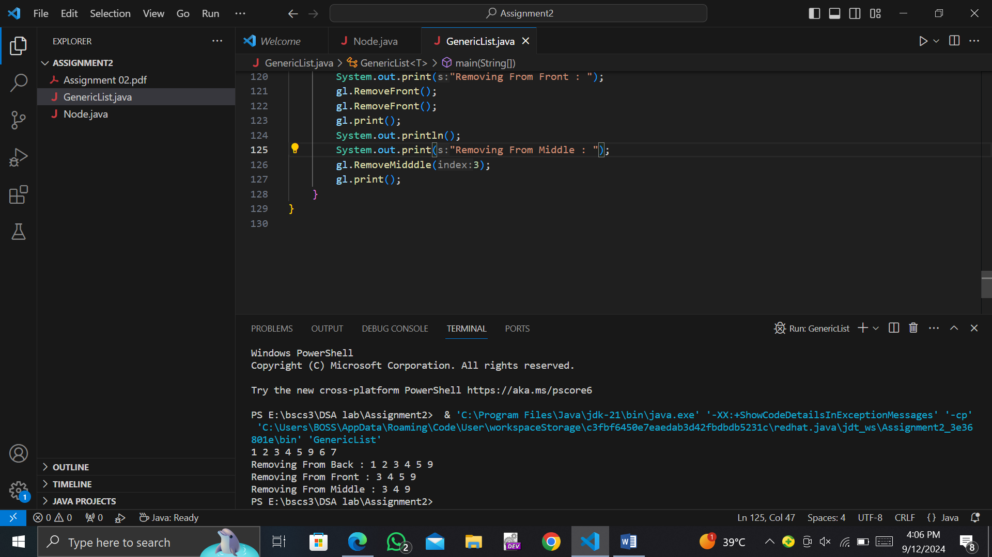

**THE END**